Project Charter

- General Information

Project Title: | Transport phone tap project | Project Working Title: | Pay App
Proponent Secretariat: | Luiz Mattos | Proponent Agency: | RADLAJ Dev
Prepared by: | Luiz Mattos, Davi Cavalcante de Carvalho, Juan Apache Ayala, Janakan Sivananthan, Rajaofera Tiana, Adityasinh Makwana

Points of Contact
List the principal individuals who may be contacted for information regarding the project.

Position | Title/Name/Organization | Phone | E-mail
Project Sponsor | Rajaofera Tiana A. | 438-728-8628 | randriam@my.centennialcollege.ca
Program Manager | Adityasinh Makwana |  | amakwan9@my.centennialcollege.ca
Project Manager | Davi Cavalcante de Carvalho | 437-326-8535 | dcavalc2@my.centennialcollege.ca
Proponent Cabinet Secretariat | Luiz Mattos | 437-985-3624 | ldasil18@my.centennialcollege.ca
Proponent Agency Head | Juan Apache Ayala | 647-9298124 | ajuancar@my.centennialcollege.ca
Customer (User) Representative(s) | Janakan Sivananthan |  | jsivana5@my.centennialcollege.ca
Other

- Executive Summary

Toronto Transport Commission (TTC) hired RACLAJ Dev to implement card payment through phone on each metro station and bus to accept other payments besides presto cards and tickets.

With the pandemic people have been using more tap methods to make payments and after noticing that TTC decided that a good future opportunity is to implement a new solution. By using a phone or debit/credit card people that occasionally use the transit transport system, including tourists, can take advantage of this feature and ride buses, subway or street cars without having to buy tickets every time.

This project will cover all the details related to the scope of the project, the next steps, goals, responsibilities, and achievements during the development of the project and all the estimations regarding the resources that are going to be needed.

- Project Purpose

1. Business Problem
The Business Problem is a question, issue, or situation, pertaining to the business, which needs to be answered or resolved. State in specific terms the problem or issue this project will resolve. Often, the Business Problem is reflected as a critical business issue or initiative in the Agency’s Strategic Plan or IT Strategic Plan.

At this point, Transit users are limited to two options of accessing the entire system, the Presto Card and paper tickets available only at subway stations. This limitation affects specially people that do not live in the city, but also some locals and is not in compliance with necessary health measures due to sanitary concerns. The business problem that the transport phone tap project is going to tackle is the necessity of people to buy tickets or presto cards for trips or short number of trips they will be making in a certain period. Another key point of this project is to decrease waste production by the usage of paper and plastic cards, promoting environmental improvements.

- Project Business Objectives

Principal Objectives | Project Business Objectives
Secure Login | Provides secure access to every user with a login and password created.
Secure Payment | Provides secure transactions with the card selected for payment.
Online access | Internet access is a must and will ensure the proper working of the app for payment.
User Friendly | Has easy follow instructions and can be self explaining.

Assumptions

- Usability

The phone payment app will make TTC trips easier by allowing them to buy transport rides without needing to buy paper tickets or cards.

- Budget and Profitability

TTC will benefit from this system with more people taking the transport by using the easy way to pay and by printing less tickets and cards, decreasing costs with printing machines and issuing Presto Cards. There is a hidden gain in health conditions to both employees and riders.
The cost of the project is estimated in $ 1,700,000.00, with a margin of error of 20%. It will also promote less cost of maintenance for the Presto machines in the order of 13%.

- Implementability

It will be easy to implement the new payment strategy into the already existing on the TTC.

- Schedule

The implementation of the new system is going to trial phase in the first quarter of 2022 and its final implementation will take place in the last quarter of 2022.

- Resources

The project will count with 13 developers, including designers and coders, as well as with 4 testers.

Project Description, Scope and Management Milestones

  - Project Description

- Project Approach:
The project will use the already existing TTC tap payment system to upload and apply the new form of payment that has been developed.

- Solution:
Create another app or function inside the presto app to offer the new payment method and facilitate others' lives.

- Customer:
People that want to take the public transport sporadically and travelers will benefit from this payment form.

- Benefits:
Allow the public to only pay the ride when it wants and no need to dispose of some product afterwards.

- Scope

The system will be web-based for mobile applications, using Amazon AWS for database solutions to promote extra layers of security over transactions. The server is an in-house Linux server where the main system will be installed.
The transport phone tap pay system will help the TTC to be more versatile in its forms of payment. This will help the population that started to use the tap payment more often as a safe distance measure.
Every TTC user in the city of Toronto, ON will be able to use and download the app using mobile devices.
Summary of Major Management Milestones and Deliverables

Event | Estimated Date | Estimated Duration
Project Charter Approved | November 22, 2021 | 3 weeks
Project Plan Completed | December 10, 2021 | 3 weeks
Project Plan Approved | December 20, 2021 | 2 weeks
Project Execution – Started | January 8, 2021 | 2 weeks
Project Execution Completed | January 22, 2022 | 17 weeks
Project Closed Out | February 8, 2022 | 20 weeks

- Project Authority

- Authorization

The TTC, Toronto Transit Commission, is the sponsor of this project, therefore it holds the authority to approve or change the project at their need and expenses.

- Project Manager

The project manager of this project is Mr. Davi Cavalcante, and his responsibilities are listed below:
- Plan and direct the development of the project
- Create and lead the work team
- Monitor the project progress
- Be the bridge between the stakeholders and the team
- Track finance aspects of the project and manage risks
- Report the steps to the stakeholders
- Evaluate the project performance

- Oversight

- Oversight development team
Program Manager - Adityasinh Makwana
Project Manager - Davi Cavalcante
Proponent Cabinet Secretariat - Luiz Mattos
Proponent Agency Head - Juan Apache Ayala
Customer Representative - Janakan Sivanthan

- Project Organization

1. Project Organization Chart

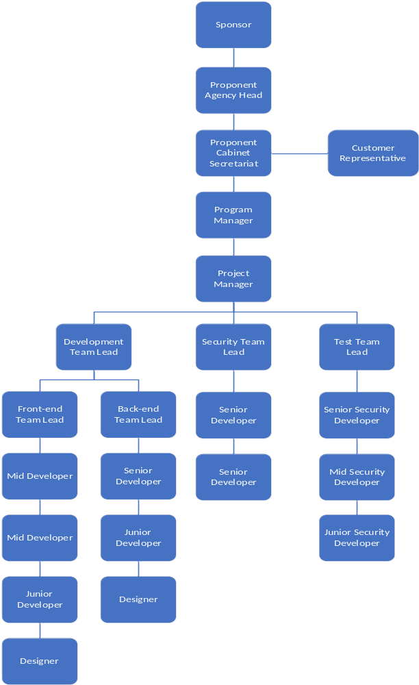

2. Organization Description

The RADLAJ Dev organization will make the best use of the available resources and manpower. The team will be following a chain of command. The sponsor will be the person that will be giving the major orders and has the final decision, hence is the one given the most resources. After that every team will respond to one team leader that will be the central point to discuss problems that have been faced and new strategies between the higher chain of command and the developers team. By applying this organization the team can assure a good quality of work and that will give what has been hired to do.

Roles and Responsibilities

- Project Sponsor
The project sponsor is responsible for the project to happen. It will provide the money and resources that we will be needing during the development of the project. However, they also lead the way the project is going since they have the bigger share on the project.

- Project Manager
The project manager is the person responsible for all the planning that a team has and organizing what they should be doing through the development phase and direct the team towards the completion of the project on due time.

- Proponent Cabinet Secretariat
The proponent cabinet secretariat is the person responsible by the agency to the designated project. It must make sure that everything is done correctly and that the responsibilities about deadlines are followed properly.

- Proponent Agency Head
The proponent agency head is the person responsible by the agency to supervise and has to make sure that everything's been done by the team. All the process and future goals are understood and they will be achieved by the end of the project.

- Customer Representative
The customer representation it's going to be the central point to make the contact between the development team and the customers. This will make it easier for the team to produce the app that will be a friendly user and will make people have a better experience using it.

- Resources

Resources | Allocation and Source
Funding | Source: TTC | Amount: $ 1,700,000
Project Team (Full and Part Time Staff) | $1,200,000
Software | $25,400
IT Equipment | $50,500
Furniture | $15,800
Data Protection | $50,000
Network System | $100,000
Cloud Server | $48,000
Management | $200,000

- Signatures

Position/Title | Signature/Printed Name/Title | Date
Proponent Cabinet Secretariat  (as required) | Luiz Matos  Luiz Mattos | October 22, 2021
Proponent Agency Head |   Juan Apache Ayala | October 22, 2021
Project Sponsor (required) |   Rajaofera Tiana Andriamasinalivao | October 22, 2021
Program Manager | Adityasinh Makwana | October 22, 2021
Project Manager (required) | Davi Cavalcante de Carvalho  Davi Cavalcante | October 22, 2021
Customer Representative | Janakan Sivananthan | October 22, 2021

